Text | Post Image
Medicaid eligibility rules are changing for adults. Take steps now so that South Dakota Medicaid can communicate changes with you.  - Update your address, phone number, and email  - Check your mail and South Dakota Medicaid online account  - Watch for official Medicaid notices  Visit dss.sd.gov/Medicaid/HR1.apx  #Medicaid #SouthDakotaDSS #StrongerCommunitiesSD | 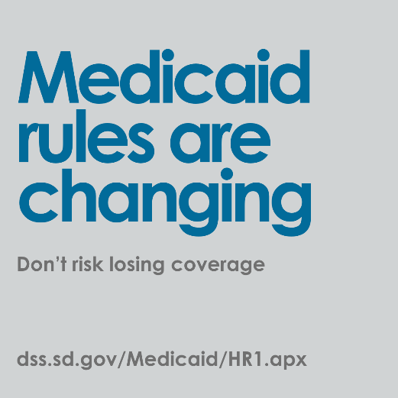
Have Medicaid? Take 5 minutes today to make sure South Dakota Medicaid has your correct:  - Home address  - Email address  - Phone number  This helps make sure you receive important notices about Medicaid rule changes and  deadlines.  Visit dss.sd.gov/Medicaid/HR1.apx  #Medicaid #SouthDakotaDSS #StrongerCommunitiesSD | 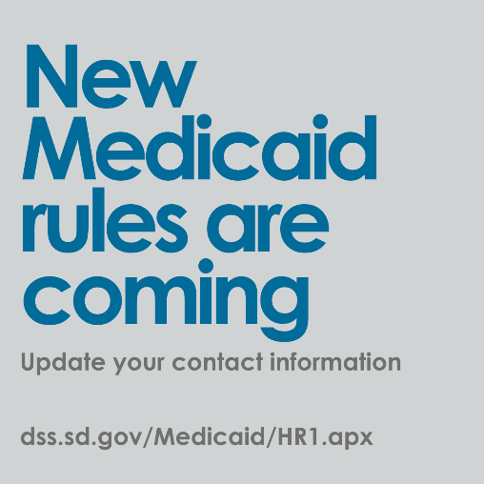
New Medicaid requirements are coming for adults.  To keep your coverage, you may need to report the hours you work, volunteer, or go to school. See how they affect you.  Visit dss.sd.gov/Medicaid/HR1.apx  #Medicaid #SouthDakotaDSS #StrongerCommunitiesSD | 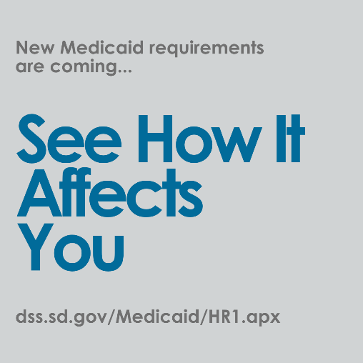
If you’re an adult on Medicaid, there are new steps to keep your coverage.  You may need to work, volunteer or go to school -- and report your hours.  See how the new requirements affect you.  Visit dss.sd.gov/Medicaid/HR1.apx  #Medicaid #SouthDakotaDSS #StrongerCommunitiesSD | 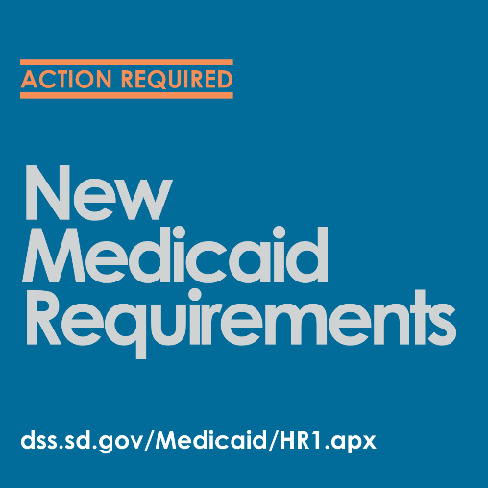
New federal rules are coming.  Medicaid changes are expected in 2027. Make sure you stay informed so you don’t miss important updates about your coverage.  Visit dss.sd.gov/Medicaid/HR1.apx  #Medicaid #SouthDakotaDSS #StrongerCommunitiesSD | 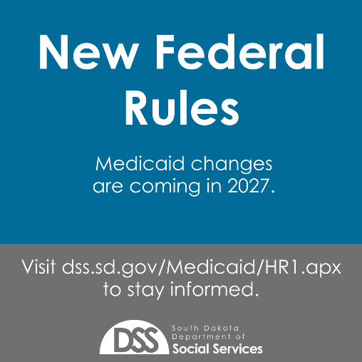
Medicaid HR1 Changes Won’t Impact Everyone  If you are Native American, tribally enrolled, or eligible for Indian Health Services, the new community engagement requirements and every-6-month renewals do not apply.  Be sure to inform DSS when you apply or renew so your information stays accurate.  Learn more: dss.sd.gov/Medicaid/HR1.apx  #SouthDakotaDSS #Medicaid #SupportSDCommunities | 