DEPARTMENT OF SOCIAL SERVICES
OFFICE OF THE SECRETARY
700 GOVERNORS DRIVE
PIERRE, SD 57501-2291
PHONE: 605-773-3165
FAX: 605-773-4855
WEB: dss.sd.gov
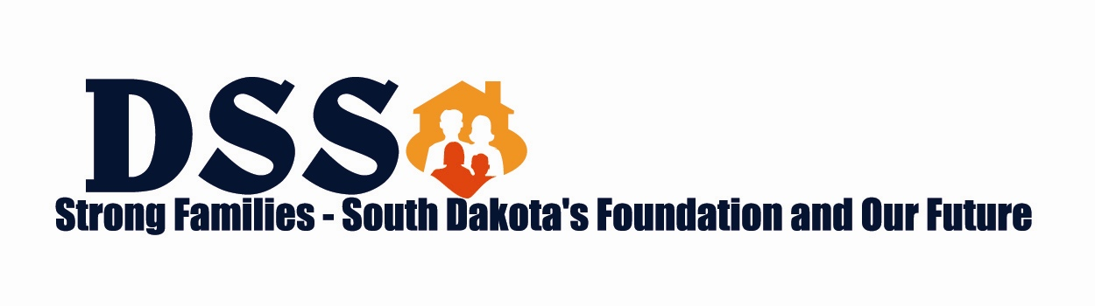
DEPARTMENT OF SOCIAL SERVICES
DIVISION OF ECONOMIC ASSISTANCE

Case #: _____________________ Section: __1__

BOARDING SCHOOL/INSTITUTION DOCUMENTATION

The following members of my household are attending boarding school:

Name of Child Name of School

The following members of my household are attending a Treatment facility (institution) temporarily.

Name of Child Name of Institution

They left (will leave) the home on .
Date

They will return on (if known).

Date

I will spend their share of the TANF/BIA/TWEP received each month on them. I will remember to report if the child changes schools, institutions or returns home.

_____________________________ _________________________
Recipient’s signature Benefit Specialist’s signature

_____________________________ _________________________
Date Date

